1. Cooper
2. 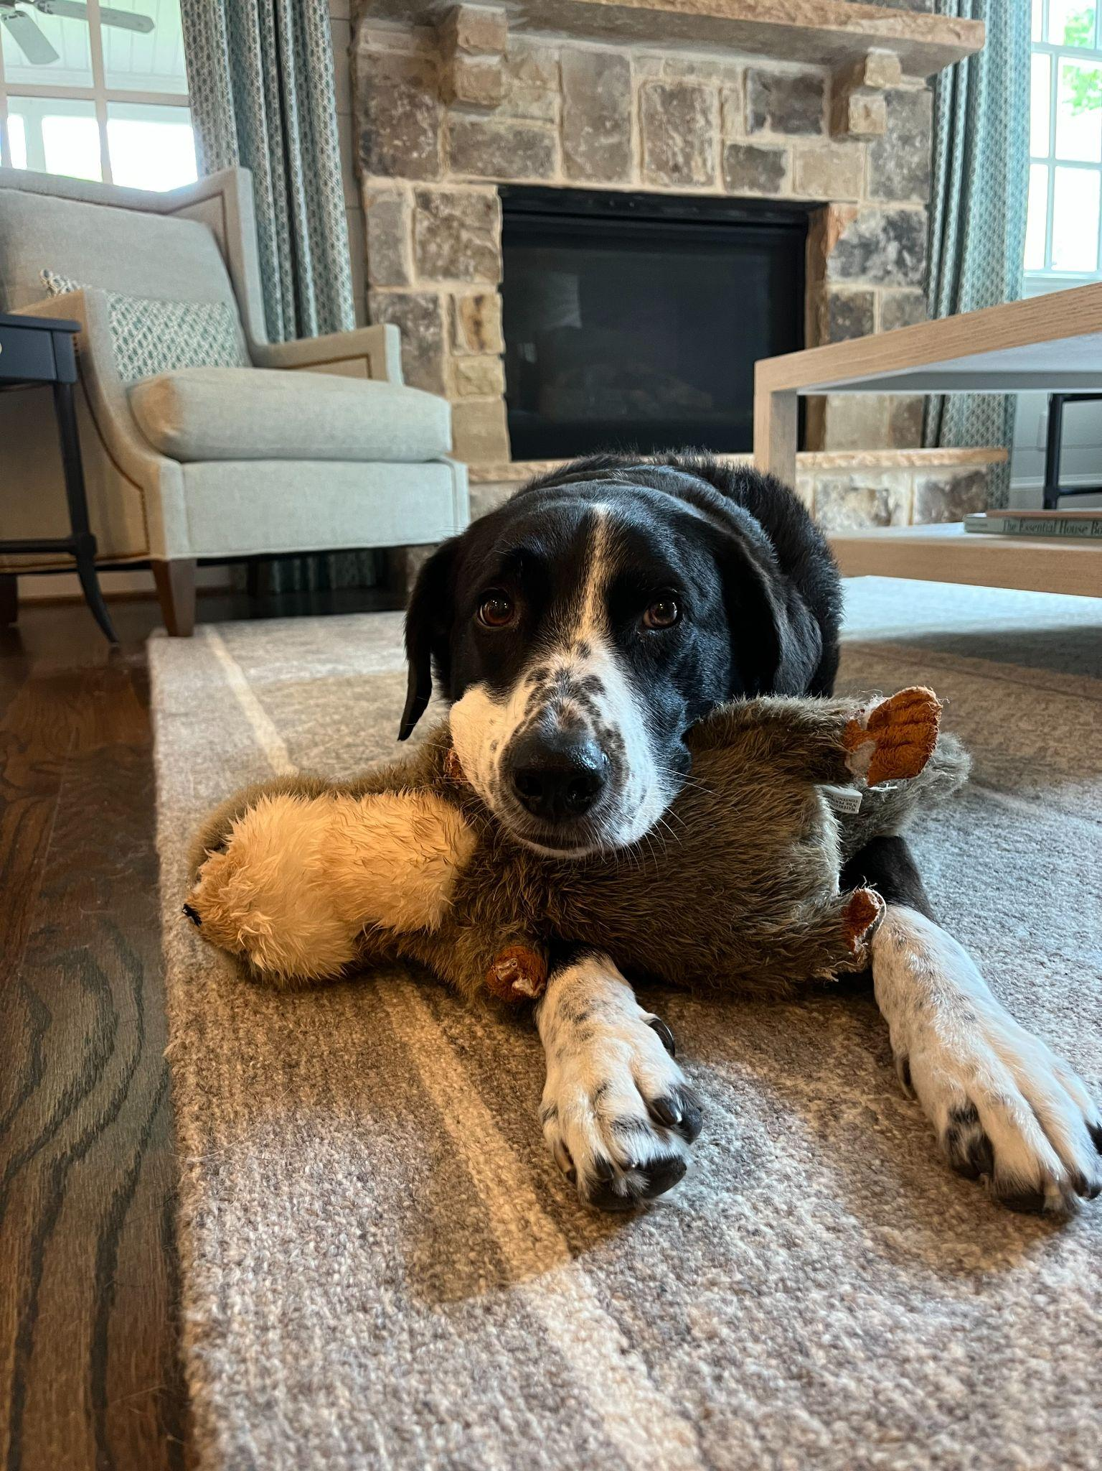
3. cooper.jpeg
4. Border collie and lab mix laying his head on his stuffed animal toy
5. Cooper is an 8yr old border collie and lab mix. We rescued him from the Humane Society as a puppy! He loves going on long walks/runs, but he stops to sniff something every few steps. He’s pretty friendly, but he loves to loudly bark at delivery people who ring the doorbell.
6. Whenever it’s movie night, Cooper has to join on the couch/bed or he feels left out. He loves to cuddle and pats on his tummy. Cooper will play fetch for about 2 or 3 rounds, but he quickly gets bored. He leaves his toys all around the house for the rest of the family to find.
7. **Photo Gallery – (Just write Photo Gallery)**
8. cooper_closeup.JPG
9. Border collie / lab mix putting his face close to the camera
10. cooper_smiling.JPG
11. Black and white colored dog smiling directly at the camera
12. cooper_flowers.jpeg
13. Border collie / lab mix sniffing a bouquet of flowers in the sun
14. cooper_puppy.JPG
15. Small border collie / lab mix puppy laying on the carpet
16. **Likes – (Just write Likes)**
17. Peanut butter
18. Going on long walks
19. Sleeping
20. Chloe Emch